

**Western Australian Certificate of Education**

**ATAR course examination, 2017**

**Question/Answer Booklet**

12 PHYSICS

Name

**Test 4 - Electromagnetism**

|  |  |  |  |  |  |  |  |  |  |  |
| --- | --- | --- | --- | --- | --- | --- | --- | --- | --- | --- |
| Student Number: In figures |  |  |  |  |  |  |  |  |  |  |

**Mark:**  In words



#### Time allowed for this paper

Reading time before commencing work: five minutes

Working time for paper: sixty minutes

**Materials required/recommended for this paper**

To be provided by the supervisor

This Question/Answer Booklet

Formulae and Data Booklet

***To be provided by the candidate***

Standard items: pens, (blue/black preferred), pencils (including coloured), sharpener, correction fluid/tape, eraser, ruler, highlighters

Special items: non-programmable calculators satisfying the conditions set by the School Curriculum and Standards Authority for this course

**Important note to candidates**

No other items may be taken into the examination room. It is your responsibility to ensure that you do not have any unauthorised notes or other items of a non-personal nature in the examination room. If you have any unauthorised material with you, hand it to the supervisor before reading any further.

**Structure of this paper**

|  |  |  |  |  |  |
| --- | --- | --- | --- | --- | --- |
| Section | Number of questions available | Number of questions to be answered | Suggested working time  (minutes) | Marks available | Percentage of exam |
| Section One:  Short Answers | 5 | 5 | 10 | 8 | 15 |
| Section Two:  Problem-solving | 7 | 7 | 50 | 44 | 85 |
| Section Three:  Comprehension | - | - | - | - | - |
|  |  |  |  | **Total** | 100 |

**Instructions to candidates**

1. The rules for the conduct of examinations at Holy Cross College are detailed in the College Examination Policy*.* Sitting this examination implies that you agree to abide by these rules.

2. Write your answers in this Question/Answer Booklet.

3. Working or reasoning should be clearly shown when calculating or estimating answers.

4. You must be careful to confine your responses to the specific questions asked and to follow any instructions that are specific to a particular question.

5. Spare pages are included at the end of this booklet. They can be used for planning your

responses and/or as additional space if required to continue an answer.

• Planning: If you use the spare pages for planning, indicate this clearly at the top of the page.

• Continuing an answer: If you need to use the space to continue an answer, indicate in the original answer space where the answer is continued, i.e. give the page number. Fill in the number of the question(s) that you are continuing to answer at the top of the page.

6. Answers to questions involving calculations should be ***evaluated and given in decimal***

***form*.** It is suggested that you quote all answers to ***three significant figures***, with the

exception of questions for which estimates are required. Despite an incorrect final result, credit may be obtained for method and working, providing these are ***clearly and legibly set out***.

7. Questions containing the instruction "estimate" may give insufficient numerical data for their solution. Students should provide appropriate figures to enable an approximate solution to be obtained. Give final answers to a maximum of two significant figures and include appropriate units where applicable.

8. Note that when an answer is a vector quantity, it must be given with magnitude and direction.

9. In all calculations, units must be consistent throughout your working.

1. Describe ***TWO*** similarities and ***TWO*** differences between the ***gravitational field*** of a

point mas***s*** and the ***electric field*** of a point charge. [4 marks]

**Similarities**

(a)

(b)

**Differences**

(a)

(b)

**Circle ONLY ONE correct answer for Multiple Choice Questions 2 to 5.**

2. current I (into page)

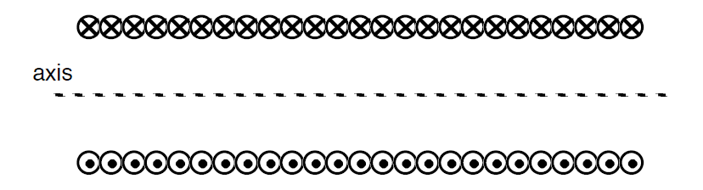

current I (out of page)

A cross section of a long solenoid that carries current ***I*** is shown above.

All of the following statements about the magnetic field ***B*** inside the solenoid are correct except:

A. Magnetic field ***B*** is directed to the left.

B. The magnitude of ***B*** is proportional to the current I.

C. The magnitude of ***B*** is proportional to the number of turns of wire per

unit length.

D. The magnitude of ***B*** is proportional to the distance from the axis of the solenoid. [1 mark]

3. A rod-shaped, positively-charged insulator is brought near a conducting sphere, and the sphere is momentarily grounded as shown in Figure 1A.

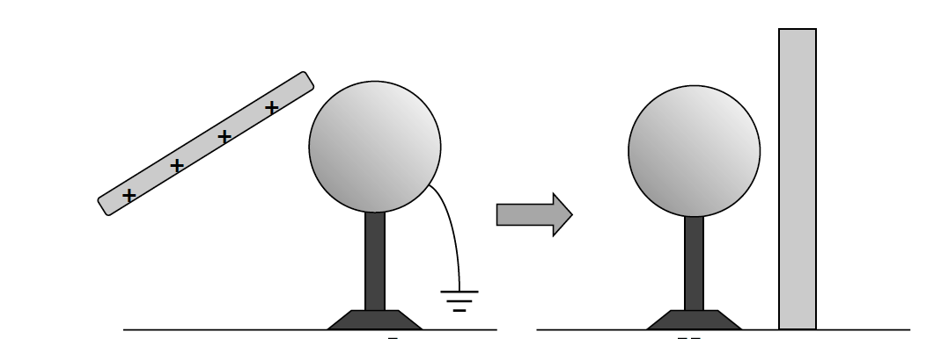

Figure 1A Figure 1B

The conducting sphere is then placed near a non-conducting plane as shown in Figure 1B. Which of the following statements is ***true*** for Figure 1B?

A. The conductor has a negative charge and is attracted to the non-conducting plane.

B. The conductor has a negative charge and is not attracted to the non-conducting plane.

C. The conductor has a positive charge and is attracted to the non-conducting plane.

D. The conductor has a positive charge and is not attracted to the non-conducting plane.

E. The conductor has no charge. [1 mark]

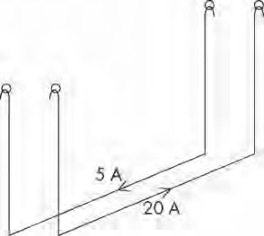4.

Note: To simplify the diagram, the external circuit has not been shown.

In an experiment to demonstrate the force between two wires carrying current, two identical long parallel wires are suspended from supports in such a way that a force between them will cause them to swing towards one another or away from one another.

A current of 5.0 A is then passed through wire A and 20.0 A through wire B.

If the currents flow in ***opposite directions***, what will happen to the wires? [1 mark]

A. A force of repulsion will appear between the wires and the wires will swing apart by equal amounts.

B. A force of repulsion will appear between the wires and the wires will swing apart, but wire B will swing out furthest.

C. A force of repulsion will appear between the wires and the wires will swing apart, but wire A will swing out furthest.

D. A force of attraction will appear between the wires and they will move towards one another by equal amounts.

5. The diagram shows a stationary conductor carrying current ***I*** ***out of the page*** near to the magnet. In what direction will a magnetic force act on the conductor?

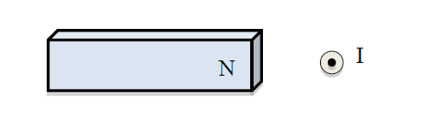

A. South B. West C. North D. East [1 mark]

6. **Figure 2** below shows two identical negatively charged conducting spheres. The spheres are tiny and each is suspended from a nylon thread.

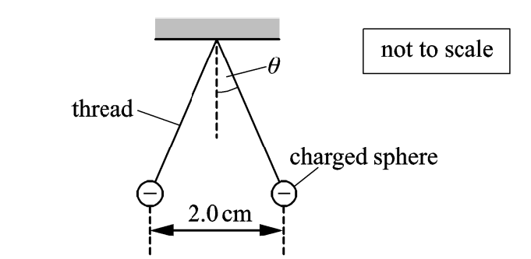

**Figure 2**

Each sphere has a mass of 6.00 x 10-5 kg and - 4.00 x 10-9 C. The separation between the centres of spheres is 2.00 cm.

(a) Explain clearly why the spheres are separated as shown in **Figure 2**? [2 marks]

(b) Calculate the angle *θ* made by each thread with the vertical. [4 marks]

7. **Figure 3** below shows two parallel vertical metal plates connected to a battery.

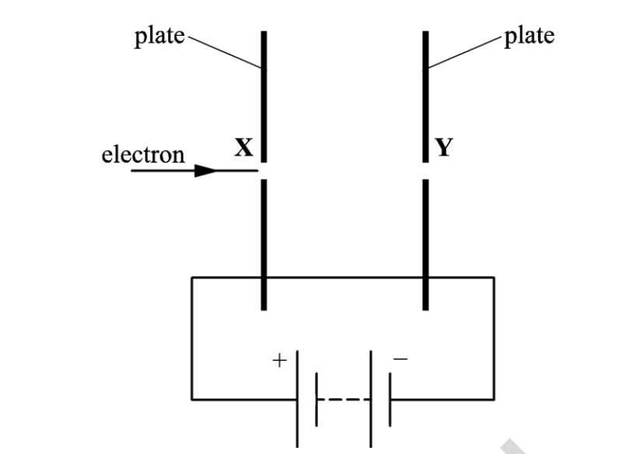

Note: To simplify the diagram, the external circuit for upper plates connected to battery terminals has not been shown.

**Figure 3**

The plates are placed in a vacuum and have a separation of 1.20 cm. The **uniform** electric field strength between the plates is 1.50 x 103 Vm-1. An electron travels through tiny holes **Y** and **X** in the plates. The electron has a horizontal velocity of 5.00 x 106 ms-1 when it enters hole **Y**.

(a) Draw ***four lines*** on **Figure 3** to represent the electric field between the parallel plates. [2 marks]

(b) Calculate the **final speed** of the electron as it leaves hole **X**. [3 marks]

8. **Figure 4** shows the circular track of a positron (having a positive charge) in a uniform magnetic field.

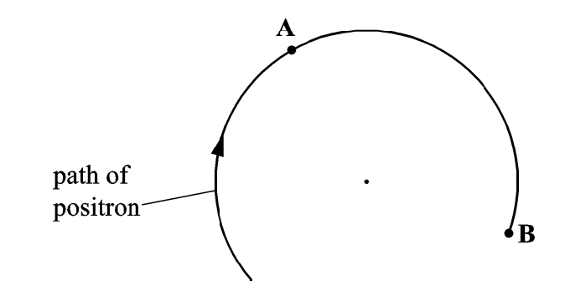

**Figure 4**

(a) At point A*,* ***indicate the direction of the magnetic force*** acting on the positron. [1 mark]

(b) State the ***direction*** of the uniform magnetic field. [1 mark]

(c) Does the magnetic force change the speed of the positron? Justify your answer.

[2 marks]

9.

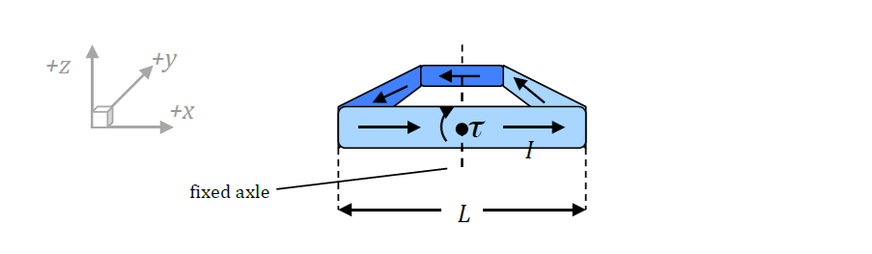

A square loop of wire, with sides of length ***L***, is oriented in the *x-y* plane, and able to rotate in a clockwise direction about an axle along the *y*-axis and running through the middle of the loop, as shown.

The loop carries a current ***I*** in the direction indicated, and a constant magnetic field ***B*** is applied so as to create a clockwise torque.

(a) State the direction of the magnetic field? Justify your answer. [2 marks]

(b) In terms of ***L****,* ***B*** and current ***I***, derive an equation for:

(i) the magnitude of the torque on the arm in the +y direction. [3 marks]

(ii) the maximum magnitude of ***total torque*** exerted. [2 marks]

10. The "motor effect" is used in a range of applications.

(a) What is the "motor effect"? [2 marks]

(b) A labelled diagram of a loudspeaker is given below.

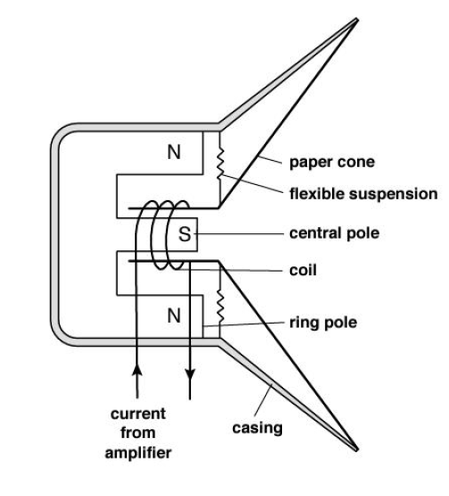

A Physics student has written the first statement to explain how a loudspeaker converts electrical signals into sound waves. Complete her explanation. [4 marks]

• An alternating electrical current is applied to the coil in the loudspeaker.

11. A student uses a cathode gun to accelerate **electrons** to different velocities and then measures the radius of curvature of the path the electrons take in a magnetic field.

The electrons enter the magnetic field at right angles to the field. A diagram of the experiment and a graph of the results obtained by the student are shown below.

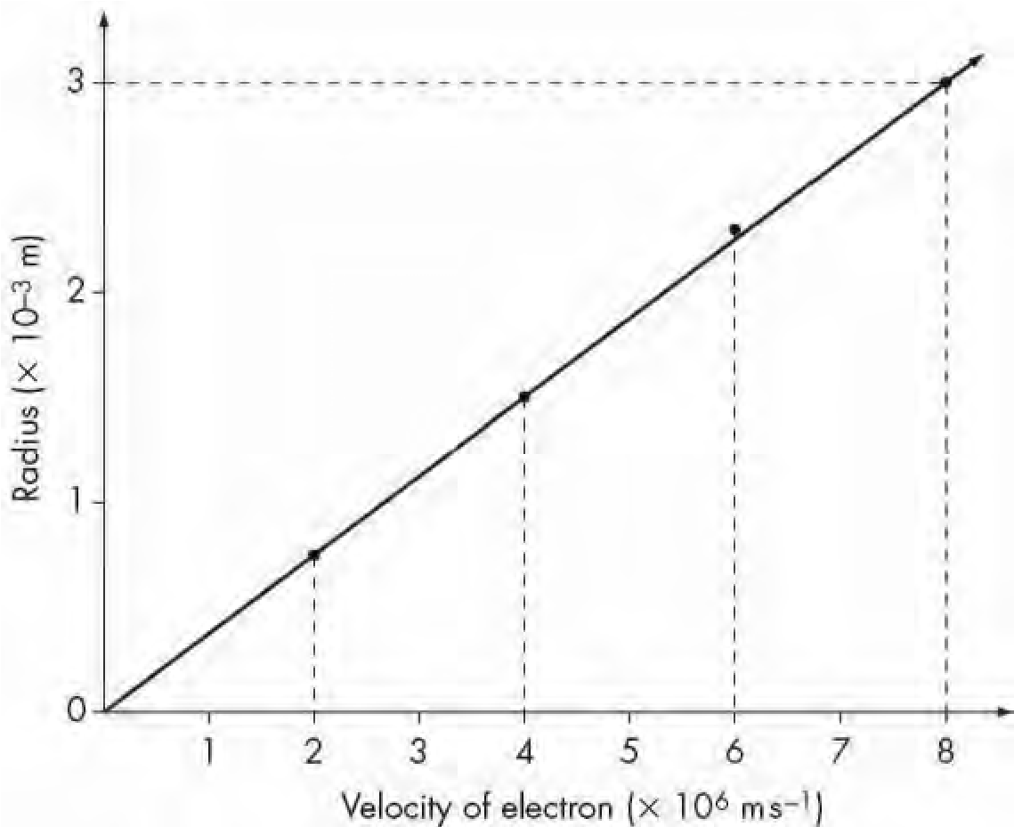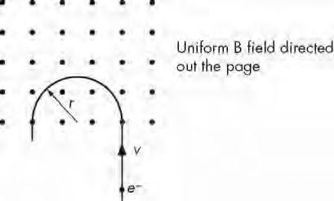

(a) By equating the centripetal force and magnetic force on a charge moving perpendicularly to a magnetic field at a constant speed (*v*), derive a general expression for the radius of curvature of the charge in the field. [2 marks]

(b) Find the gradient of the graph. [2 marks]

(c) Using your answer to part (b), or otherwise, calculate the strength of the magnetic field used in this experiment. [2 marks]

(d) (i) In the diagram below, sketch the magnetic field between the two poles.

[1 mark]

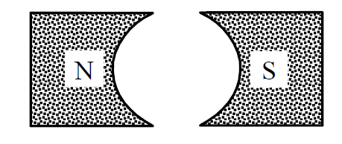

(ii) Identify the reason for using the above field in a motor. [1 mark]

12. A wire carrying an electric currentis placed between the poles of a horseshoe magnet. The 6.35 cm long conductor carries a current 4.80 A and the magnetic field between the poles of the magnet has a strength of 0.540 T.

(a) On the diagram, carefully illustrate the resultant magnetic field and the direction of the force experienced by the conductor? [3 marks]

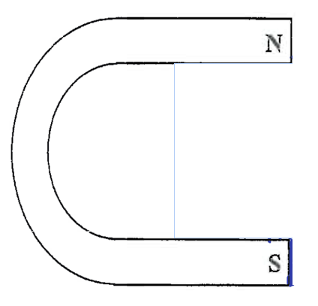

***I*** in

(b) Determine the magnitude of the force experienced by the conductor wire? [2 marks]

13. Calculate the force on a small airplane, which has acquired a nett charge of 1.55 x 103 µC and moves with a speed of 1.20 x 102 ms-1: [3 marks]

(a) parallel to the Earth’s magnetic field of 5.00 x 10-5 T.

(b) perpendicular to the Earth’s magnetic field of 5.00 x 10-5 T.